HIGH SCHOOL: |  |  |  |  |  | BIG SKY PATHWAY PROPOSAL
COLLEGE: Helena College University of Montana |  |  |  |  |  | 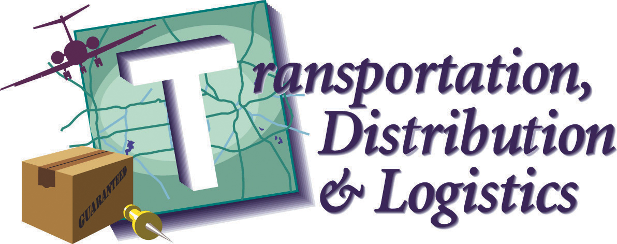
COLLEGE DEGREE PROGRAM:
Cluster Overview:  Jobs in the Transportation, Distribution, and Logistics career cluster involve the planning, management, and movement of people, materials, and goods by road, air, rail, and water, as well as related professional and technical support services such as transportation infrastructure planning and management; logistics services; and mobile equipment and facility maintenance. |  |  |  | Pathway Options:  - Transportation Operations  - Logistics Planning and Management Services  - Warehousing & Distribution Center Operations  - Facility and Mobile Equipment Maintenance  - Transportation Systems/Infrastructure Planning, Management and Regulation  - Health, Safety and Environmental Management |  | Occupation Examples:  Dispatchers, Aircraft Mechanic, Airline Pilots, Air Traffic Controllers, Bus Drivers, Diesel Mechanics, Truck Drivers, Locomotive Engineers, Cargo and Freight Agents, Mass Transit Transportation Managers, Shipping and Receiving Clerks  For a complete listing, go to:  http://online.onetcenter.org/find/career?c=16&g=Go
SUGGESTED HIGH SCHOOL COURSES
9th | Graduation Requirements  Workforce/2-Year College Prep |  |  |  |  |  |  | Recommended CTE Cluster Foundation Course(s):
 | 4-Year MT College/Univ Prep (Rigorous Core)
 | CTE and/or Electives |  |  |  |  |  |  | Recommended CTE Pathway Courses:
10th | Graduation Requirements  Workforce/2-Year College Prep
4-Year MT College/Univ Prep
(Rigorous Core)
 | CTE and/or Electives |  |  |  |  |  |  | Other Recommended CTE Courses:
11th | Graduation Requirements  Workforce/2-Year College Prep
4-Year MT College/Univ Prep
(Rigorous Core)
 | CTE and/or Electives
12th | Graduation Requirements  Workforce/2-Year College Prep |  |  |  |  |  |  | Career & Technical Student Organization(s):
4-Year MT College/Univ Prep
(Rigorous Core)
 | CTE and/or Electives
ADVANCED LEARNING OPPORTUNITIES
High School to College/Career Linkages
CTE START courses:

Advanced Placement or IB courses:

Dual Enrollment courses: M11T Technical Math? WRIT121 Intro to Tech Writing?
Online courses:
Other: work experience:

POSTSECONDARY PROGRAM OF STUDY (72 credits)
 |  | Math |  | English | Major |  | Other
Semester 1 |  | M11T Technical Math 3cr |  |  | AUTO104 Automotive Mechanics 2cr  AST108 Auto Manual Drive Trains 6  AST130 Intro to Auto Electronics 7
Semester 2 |  |  |  |  | AST160 Auto Engine Repair 6  AST172 Auto Heating/Air Conditioning 5  Electric/Electronics Systems II 4
Semester 3 |  |  |  | WRIT121 Intro to Tech Writing 3cr | AST118 Brake Chassis 6  AST262 Engine Performance I 8cr
Semester 4 |  |  |  |  | AST264 Engine Performance II 5cr  AST 270 Auto Transmissions/Transaxles 7  AST280 Applied Lab Experience Light Repair 4 |  | HR110T Career Development and Human Relations

MONTANA POSTSECONDARY OPPORTUNITIES

Montana University System Degree and Program Inventory: http://www.homepage.montana.edu/~mus/drginv/
Your Guide to Montana's Certificate and Associate Degree Programs: http://mus.edu/twoyear/YourGuide.html
MSU Two Year Colleges and Programs:  City College MSUB—Billings (CC); Great Falls College MSU—Great Falls (GFC); Helena College UM—Helena (HC) Highlands College MT Tech—Butte(HC-Tech); Missoula College UM—Missoula (MC); Gallatin College MSU—Bozeman(GC) |  | Community Colleges:  Dawson Community College (DCC)  Flathead Valley Community College (FVCC)  Miles Community College (MCC) | Tribal Colleges: Aaniiih Nakoda College (ANC);Blackfeet Community College(BCC); Chief Dull Knife College (CDKC);Fort Peck Community College (FPCC);Little Big Horn College (LBHC);Stone Child College (SCC);Salish Kootenai College (SKC) |  | Four Year Colleges/Universities: MSU—Bozeman; MSUB—Billings; MSUN—Havre; MT Tech—Butte; UM—Missoula; UMW—Dillon
MILITARY | - Requires diploma or GED  - 17 with parental consent; 18 without |  |  | Air Force, Air Guard, Army, Coast Guard, Marines, and Navy  For more information: http://todaysmilitary.com
PROFESSIONAL CERTIFICATE | - Requires diploma or GED  - Less than 30 credits; little/no general ed credits  - Complete in one year or less |  |  | AutomotiveTechnology ― FVCC  Truck Driving ― MCC
APPRENTICESHIP | - Requires diploma or GED  - Must be at least 18  - Minimum 2,000 hours of supervised experience |  |  | Aircraft Mechanics, Avionics Technicians, Bus and Truck Mechanics, Diesel Engine Mechanics, Heavy Equipment Mechanics, Material Coordinators/Shipping & Receiving Clerks  See the MT Dept of Labor website for more information:  http://wsd.dli.mt.gov/apprenticeship/default.asp
CERTIFICATE OF  APPLIED SCIENCE | - Requires diploma or GED  - 30-45 credits; limited general education credits  - Complete in one year or less |  |  | Automotive Collision & Refinishing ― CC, GFC  Automotive Technology ― HC Tech, MSUN, CC, MCC, FPCC  Diesel Equipment/Technology ― CC  Heavy Equipment Operation ― MC, FVCC, MCC, FPCC, BCC  Highway Construction Worker ― SKC  Recreational Power Equipment ― MC  Truck Driving ― FPCC
ASSOCIATE’S OF APPLIED SCIENCE DEGREE | - Requires diploma or GED  - 60-72 credits; includes 15-25 general ed credits  - Complete in two years (if prepared academically in math and English) |  |  | Automotive Collision & Refinishing ― CC  Automotive Technology ― HC, CC, MSUN, MCC, FPCC  Aviation ― GC  Aviation Maintenance ― Helena College  Diesel Equipment/Technology ― CC, HC, MC, MSUN
BACCALAUREATE DEGREE | - Requires 4-year college prep for admission  - 128 credits (approximately)  - Complete in four years |  |  | Diesel Technology ― MSUN
Degree and Program Inventory above may not be all inclusive

