Centralized Content Management
The Centralized Content Management tool in Moodle allows instructors to create content at scale and replicate it throughout their courses.
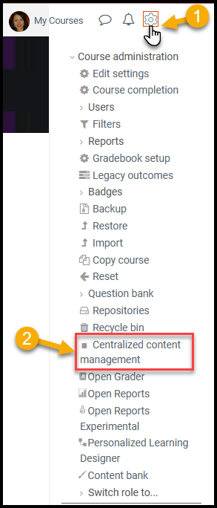
*Please note that at the moment the tool only supports 4 types of resource: File, Page, Label and SCORM.*

There are three steps to create content in the Centralized Content Management (CCM) tool:
- Create a master: Click on the Create Master button or on the tab. Search for a course that contains the resource you want to copy to create the master resource.
Select the recourse and copy it as a Master in CCM.
Whatever change you make to this master resource will live in the CCM tool.

- Create a replica: Once you have created your master please click on the button Create replica.
Select the master you want to replicate, select the courses and corresponding sections where you want to add your resources. You can add as many courses as needed. Finish by creating the replicas.

- Changes to masters and propagation: Modify your masters in the CCM tool and save the changes. Then, select the replicas where you want your changes to be implemented. Click the propagate button. It can take up to 5 minutes to see the changes in all the replicas.

Contact the eLearning Office if you need help:

Office Phone: (406) 447-6364

Texting: (406) 209-9748

Email: eLearning@helenacollege.edu

Booking: Meeting with eLearning Office (virtually via TEAMS or in person in DON 203)

